# CHAPTER 1

# INTRODUCTION

# In day-to-day life there is lots of increment in population. Now a day most of the people are using their own vehicles. Due to this traffic work has been increased. So, this work deals with the creation of a real-life android application, where all the necessary details of a vehicle (i.e., Registration Certificate, Insurance Policy and vehicle's Pollution Under Control Certificate) are coordinated and stored by the database of RTO admin without much effort and it can be accessed by both the user and vehicle inspector. We can digitalize all documents which are taken care of without so much efforts and hard work. In existing process is done manually it takes lots of time and also many citizens have their fake documents.

# "Unique QR Code for Vehicle Verification" is for traffic police using QR code to avoid to carry physical documents it also avoids some security Issues and also reduce following:

# All documents related to vehicle and owner can now be access through smart phone.

# This contains one application which can be accessed by both user and traffic police verifier.

# The traffic police will simply scan the QR code on vehicle and then all documents will display on the application login by unique ID (registration number of vehicle) and password.

# VISION, MISSION AND OBJECTIVES

**Vision:** To digitize all the documents of a vehicle.

**Mission:** To design a user friendly and convenient android application which provides all the required documents used for vehicle verification.

**Objectives:**

* Notify users to renew the documents before expire date.
* Only the owner and Verifier has the right to see the documents.
* Ensure authenticity of documents and there eliminate the use of fake documents.

# 1.2 SCOPE OF THE PROJECT

# An application, which will facilitate the user for not worrying about carrying the documents of their vehicle. We can digitalize all documents, which are taken care with so much efforts and hard work. This application will make sure you have all the documents. Different documents like License, PUC, RC Book, Insurance papers can be easily handled. During accidents by using vehicle documents, it is easy to recognize the drivers.

# 1.3 PROBLEM STATEMENT

# To develop an application to digitalize all the documents required to vehicle identification.

# 1.4 EXISTING SYSTEM

# In existing system user needs to carry his/her smartphone to access their vehicle documents. If user forgets to carry his/her smartphone they cannot access their vehicle documents which may put user in some serious trouble.

# 1.5 PROPOSED SYSTEM

# The proposed system will overcome the limitations of existing system by using QR code to store and access the documents.

# CHAPTER 2

# LITERATURE SURVEY

# [1]. Ms. Ankita V. Ghodke, Prof. Rahul V. Dagade “Vehicle Verification system using Advanced Digi-Locker system”, International Journal of Computer Applications. 8th Aug 2018.

# The Digital Locker is storage facility avoid to carry the physical documents it digitalizes the documents. This Application Contains two sub-Application: - User application and vehicle verification application. Improving Transparency in system and lots of time should be saved. The proposed system can save the amount of time of user and police officer. This RTO Digi-locker mechanism aims to eliminate the physical documents work. This work deals with the creation of an android application where all details of the vehicle are stored.

# One of the newest developments is the use of Quick Response codes (QR codes) to quickly data scanning and readable technique by using a smart phone camera. This application is used for solving the real-time problem which takes safe custody of the important documents such as driving license, PUC, insurance, RC book etc. which verify the vehicle and user digitally, so result is provide much more transparency, authenticity, and reduce corruption of fake documents by users and also reduces the administration overhead of RTO Admin by minimizing the use of paper documents.

# [2]. David Lorenzia, Jaideep Vaidya, Soon Chun, Basit Shafiq, Vijayalakshmi Atluri “Enhancing the government service experience through QR codes on mobile platforms”, Elsevier (Journal). 6th Jun 2014.

# Digital government is universally gaining acceptance from the public becomes more technologically advanced. It is critical for the government to develop new technology for minimizing expenditure and maximizing utility of services to the taxpayers and users. While administrative services have been easily shifted to the digital world, there are still many important citizen-based services that have not yet been effectively migrated. They integrate QR code systems and corresponding smart phone applications into existing government services with the goal of providing a new level of interactivity for the public QR codes are used in marketing promotions such as discount coupons, advertisements, and supply chain management areas far beyond their original imagined use cases which were tracking automobile parts in the auto manufacturing industry. QR code provides a cheap, easy, and secure method to transmit information to individuals who have the ability to read the code.

# [3]. Mr. Komal chorhgade, Mr. Piyush Dahiwele, Prof. Prajakta pise “RTO automation using QR code”, IRJET. 4th Apr 2018.

# In RTO it had process of registration of driving license, their documents data to be stored in the database in which they access from that database whenever required. This system also provides feature for detecting the fake user. Administrator had rights to enter and process the data of applicants. Any person who has been authorized by the administrator can utilize the services of his system. An authorized user should have a user name and a password.

# [4]. Mr. Nilesh R. Patil, Prof. Rajesh Dharmik “Secured Cloud Architecture for Cloud Service Provider”, WCFTR. 2016.

# Here they described the security architecture for cloud service provider there are three different services like SAAS, IAAS, PASS, so the lots of privacy and security issue are generating for storing the information on the cloud network. After the survey, the private cloud for storing the information of citizens. This cloud model provides the more security because only authenticate person can access the information from the cloud.

# [5]. Mr. Paritosh Patil, Mr. Shrinivas Shah, Ms. Pooja Shivale, Prof. Murali Parameswaran “Park IT- QR based vehicle security”, IRJET. 8th Aug 2020.

# Here in this project, they implemented the parking system based on the QR code on the car. The system scans the QR code of the car on entering the parking lot the system guides the user to the specific parking area which is allotted specifically for that car (Assumed that the parking is specifically for the group of people who are living in that locality), for this the user should register into the system and they should provide the required details. Here the system also saves the logs of all the cars entering time and leaving time for an additional security.

**[6]. Krassie Petrova, Adriana Romanello, B. Dawn Medlin, and Sandra A. Vannoy, “QR Codes Advantages and Dangers”, ICETE. 2016.**

Here we learnt about the evolution of QR codes, creation of QR codes, uses of QR codes, advantages of QR codes when compared to bar code, dangers of QR codes and how to tackle that.

# [7]. Ms. Bhavani Ratakonda1, Mr. Ajay Therala, and Mr. Chanikya Kumar Hanumanthu “Driving license detection using QR code”, ICMED. 2020.

# Here in this project, they created system in which the RTO admin can issue a driving license including a QR code which can be used to verify driving license of the user. Anyone who gets the permission of admin can issue driving license and QR code to the user. Here admin can permit some users (Traffic inspectors) to retrieve the data from scanning the QR code given to the user.

# [8]. Ms. Anusha Tengse, Ms. Sonali Shetty “QR Codes for Vehicle Identification and Registration”, KSCST. 2018.

# In this project they implemented a system which takes the image of a vehicle and extracts the license number from that image and then further process to retrieve the data of a vehicle and its owner’s details only authorized users can access the data of the vehicle. The system allows user to modify the data whenever required. Admin have permits to disqualify the users QR code if the data provided by the user is not able verify.

# [9]. Mr. Manjunath S Patil, Mr. Basavaraj K Madagouda, Mr. Vinod C Desai, “E-RTO Management System”, IJERT. 2013.

# “E-RTO management System” which is design keeping in a view to make the existing registration and insurance system easier and faster. It included the entire registration and insurance procedure starting from the initial phase of entering till the result. Also, security was provided in the intermediate stages starting from the receiving of the application form to revealing the applicant number along with the expiry date of license are being dealt. Administrator was provided for authentication purpose as well as it could handle all the database of E-RTO and manage all the process. He had rights to approve learning license number, permanent license number, pass the vehicle registration number, offer insurance details to the user, etc. Facilities were provided by administrator.

# [10]. Mr. Sarbjit Kaur, “An Automatic Number Plate Recognition System under Image Processing”, MECS. 2016.

# Here he designed a system to capture the image of the number plate of a vehicle using a camera and the details are being retrieved using the character segmentation which is done by a feature extraction optical character recognition algorithm (OCR). Then the details retrieved from the number plate in text format is used to extract all the important information of the vehicles. The above approach includes image processing hence it contains the disadvantages of image processing.

# [11]. Mr. Maysaa Abd Ulkareem Naser, Mr. Eman Talib Jasim, Mr. Haider M. Al-Mashhadi “QR code based two-factor authentication to verify paper-based documents”, TELKOMNIKA. 2018.

# In this project, they have implemented QR code based two-factor authentication to verify paper documents. There idea was to print a QR code on the paper documents which stores the data of the document in it. On scanning that code, the application will redirect user to the official website and retrieves the data and show to that user if the user has an access to the data. By doing this they want to differentiate between original and fake documents.

# [12]. Ms. Sumeena S, Mr. Muhammed Hassan A K, Ms. Varsha Vasav, Ms. Amrutha Vishnupriya S “Unique QR code FOR vehicle verification”, IRJET. 7th July 2020.

# In this paper, they have implemented a system in which users need to go to the RTO officer to scan and upload their vehicles documents on verification user will be getting the unique QR code which can be used to verify documents of the vehicle.

# In our project users need not to go to RTO office to upload their vehicle’s documents, they should upload the photocopy of their vehicle's original documents which will be verified by the RTO admin. On verification the user will be able to generate QR code which can be used for their vehicle documents verification.

# [13]. Mr. K. Venkateswarlu, Ms. K. Ramya Thanuja,” Vehicle theft detection using QR code”, UGC Care Group I Journal. 14th Jan 2021.

# In this project, they have implemented a system in which user should register into their application and then provide required details and documents. On verification the QR code will be generated which should be applied to a vehicle. User can register the complaint using their android application. On scanning the QR code it will display weather the vehicle is theft vehicle or not.

# CHAPTER 3

# SYSTEM ANALYSIS AND REQUIREMENTS

**3.1 REQUIREMENT SPECIFICATIONS**

**3.1.1 HARDWARE REQUIREMENTS**

* RAM: 8GB
* Processor: 2.5 GHz, i5
* Hard disk drive: 500GB
* Ports: USB
* Input: keyboard
* Monitor: LCD

**3.1.2 SOFTWARE REQUIREMENTS**

* Operating System: Windows 11
* Language: Java, XML
* Database: Firebase
* IDE: Android Studio

**3.2 FUNCTIONAL REQUIREMENTS**

Functional requirement means an operation of system software at which it describes how actually the system will perform or work for a specified input or situation. This section analysis various angles of the functionality to be developed. This application consists of following modules.

**Register user:** In this module new user will be able to register into the system, to register user need to provide Name, Email id, Phone number. Email is verified by generating a link to the user entered mail, on click user mail will be authorized. Phone number of the user is also verified through one time password (OTP).

**Log in:** The user logs into the application with their Email and password. If the user id and password entered is valid, user will be redirected to next process else error message will be displayed.

**Forgot password:** Here user will be able to reset his/her password. User should enter his/her registered email and click on submit. By doing this user will get a reset link for a mail in which users can reset their password.

**Add vehicle:** Here users will be able to add their vehicle details, on successful verification vehicle will be added to my vehicles list.

**Generate QR code:** After adding the vehicle successfully user will be able to generate QR code which will be used to verify user’s vehicle.

**QR code Scanner:** Here inspector will be able to scan a vehicle’s QR code and check the validity of a vehicle.

**3.3 NON-FUNCTIONAL REQUIREMENTS**

* **Completeness:** refers to the availability of all the features listed in the requirements. The Proposed system implements all the features listed in requirements like maintaining the correct records of the user's vehicle, User details etc.
* **Security:** The application provides security by giving the users with their own user id and password which is stored in the cloud securely. Users can also update their password at any time.
* **Correctness:** refers to the correct operation of application. For tester it is with respect to requirements; for user, it is with respect to user manual. Here system shall achieve correctness by performing each operation correctly and giving assistance to user about the system.
* **Reliability:** The probability of failure-free operation of the system over a given time interval under given conditions. Our system achieves reliability by getting the exact documents.

# CHAPTER 4

# DESIGN

**4.1** **SYSTEM ARCHITECTURE**

A system architecture is the conceptual model that defines the structure, behaviour, and more views of a system. An architecture description is a formal description and representation of a system, organized in a way that supports reasoning about the structures and behaviour of the system.

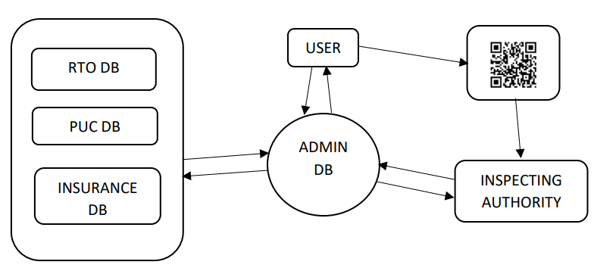

# Fig 4.1 SYSTEM ARCHITECTURE

**4.2 USECASE DIAGRAM**

A use case diagram is a graphical representation of user's possible interactions with a system. A use case diagram shows various use cases and different types of users in the system. In this system there are two types of users one is the user and another is Inspector. User needs to register and login into the system and they can add vehicle details and generate the QR code. Inspector can scan the code and see whether the user’s vehicle documents are valid or not.

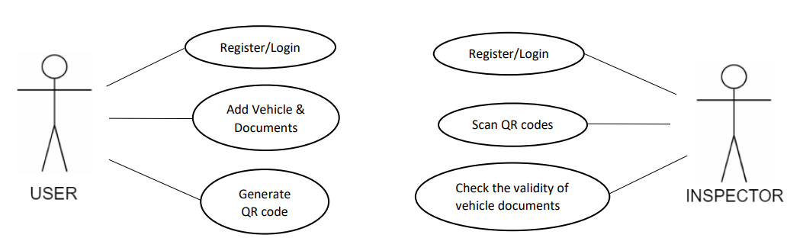

# Fig 4.2 USE CASE DIAGRAM

**4.3 DATA FLOW DIAGRAM**

A data-flow diagram is a way of representing a flow of data through a process or a system.  The DFD also provides information about the outputs and inputs of each entity of a system.

# 0-Level DFD:

# It is also known as context diagram. It’s designed to be an abstraction view, showing the system as a single process with its relationship to external entities. It represents the entire system as single bubble with input and output data indicated by incoming/outgoing arrows

# 

# Fig 4.3.1 Level-0 DFD

# 1-Level DFD:

# In 1-level DFD, context diagram is decomposed into multiple bubbles/processes. In this level we highlight the main functions of the system and breakdown the high-level process of 0- level DFD into sub processes.

# 

# Fig 4.3.2 Level-1 DFD

# 2-Level DFD:

# 2-level DFD goes one step deeper into parts of 1-level DFD. It can be used to plan or record the specific/necessary detail about the system’s functioning.

# 

# Fig 4.3.3 Level-2 DFD

**4.4 SEQUENCE DIAGRAM**

A sequence diagram is a Unified Modeling Language (UML) diagram that illustrates the sequence of messages between objects in an interaction. A system sequence diagram should specify and show the following:

* External actors
* Messages (methods) invoked by these actors
* [Return values](https://en.wikipedia.org/w/index.php?title=Return_values&action=edit&redlink=1) (if any) associated with previous messages
* Indication of any loops or iteration area

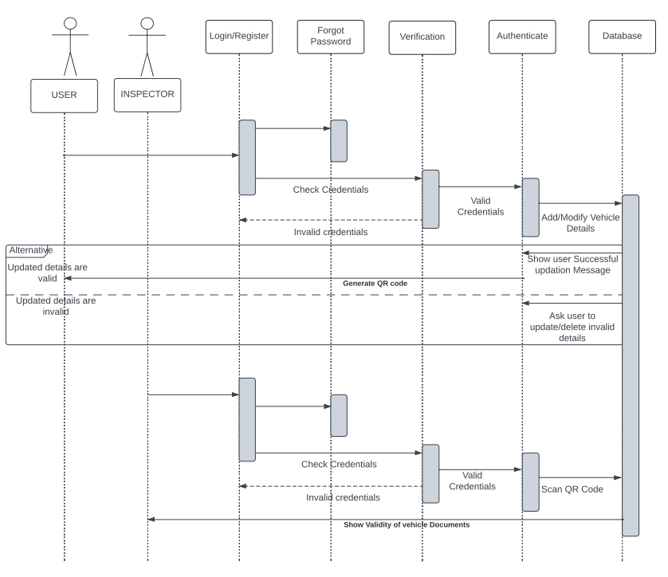

**Fig 4.4 SEQUENCE DIAGRAM**

**4.5 ER DIAGRAM**

# An Entity Relationship (ER) Diagram is a type of flowchart that illustrates how entities relate to each other within a system. Here the entities are User, Vehicle, PUC, RC, Insurance. All the entities are related to each other as shown in the below diagram.

# 

**Fig 4.5 ER Diagram**

**4.6 FLOWCHART**

A flowchart represents a workflow or process of a system. In this system user needs to register and login into the system after login users can add/modify vehicle details. If all the entered details are verified and valid, user can generate QR code which will store whether the vehicle documents are valid or not. On scanning the QR code we can check validity of the vehicle documents.

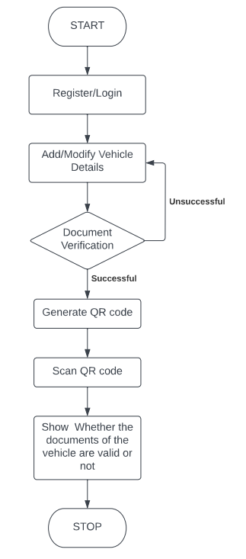

**Fig 4.6 FLOWCHART**

# CHAPTER 5

# IMPLEMENTATION

# 5.1 PROGRAMMING LANGUAGE SELECTION

# Java is a little, basic, safe, item situated, translated or rapidly improved, byte coded, engineering, waste gathered, multithreaded programming dialect with a specifically exemption taking care of for composing circulated and powerfully extensible projects.

# 5.2 SELECTION OF PLATFORM

# The Android platform is a platform for mobile devices that uses a modified Linux kernel. The Android Platform was introduced by the Open Handset Alliance in November of 2007. Most applications that run on the Android platform are written in the Java programming language.

# As android is very popular mobile operating system, it’s reach to public is more when compared to other mobile operating system available in the market. As android is available in variety of price segments we will be able to reach more number of audience.

**5.3 OVERVIEW OF MODULES**

The proposed App has following modules.

**Register user:** In this module new user will be able to register into the system, to register user need to provide Name, Email id, Phone number. Email is verified by generating a link to the user entered mail, on click user mail will be authorized. Phone number of the user is also verified through one time password (OTP).

**Log in:** The user logs into the application with their Email and password. If the user id and password entered is valid, user will be redirected to next process else error message will be displayed.

**Forgot password:** Here user will be able to reset his/her password. User should enter his/her registered email and click on submit. By doing this user will get a reset link for a mail in which users can reset their password.

**Add vehicle:** Here users will be able to add their vehicle details, on successful verification vehicle will be added to my vehicles list.

**Generate QR code:** After adding the vehicle successfully user will be able to generate QR code which will be used to verify user’s vehicle.

**QR code Scanner:** Here inspector will be able to scan a vehicle’s QR code and check the validity of a vehicle.

**CHAPTER 6**

**TESTING**

This chapter gives the outline of all the testing methods that are carried out to get a bug free application.

**6.1 TESTING PROCESS**

Testing is an integral part of software development. Testing process, in a way certifies, whether the product, that is developed, compiles with the standards, that it was designed to. Testing process involves building of test cases, against which, the product has to be tested. In some cases, test cases are done based on the system requirements specified for the product/software, which is to be developed.

* 1. **TESTING OBJECTIVES**

The main objectives of testing process are as follows:

* Testing is a process of executing a program with the intent of finding an error.
* A good test case is one that has high probability of finding an as yet undiscovered error.
* A successful test is one that uncovers an as yet undiscovered error.

**6.3 LEVELS OF TESTING**

Different levels of testing are used in the testing process; each level of testing aims to test different aspects of the system. The basic levels are unit testing, integration testing, system testing and acceptance testing.

**6.3.1 UNIT TESTING**

Unit testing focuses verification effort on the smallest unit of software design the module. The software built, is a collection of individual modules. In this kind of testing exact flow of control for each module was verified. With detailed design consideration used as a guide, important control paths are tested to uncover errors within the boundary of the module.

|  |  |  |  |
| --- | --- | --- | --- |
| **MODULE** | **INPUT** | **EXPECTED OUTPUT** | **ACTUAL**  **OUTPUT** |
| Mobile No Verification | Mobile No | To generate and validate the OTP. | Generates the OTP and validates the mobile No. |
| Forgot Password | Registered Email ID | To generate and send a reset password link to the entered email. | Generates the password reset link to the entered mail. |
| Add Vehicle | Vehicle No | Adds vehicle into the user’s account if the entered vehicle number is valid. | Adds Vehicle number if the entered vehicle number is valid. |
| Generate QR code | Vehicle No | To generate QR code for the entered vehicle number | Successfully generates QR code. |
| Scan QR code | QR code | To show the details of vehicle if scanned QR code is valid. | Successfully shows the details of the vehicle. |

**Table 6.3.1 UNIT TESTING**

**6.3.2 INTEGRATION TESTING**

The second level of testing is called integration testing. In this, many class-tested modules are combined into subsystems, which are then tested. The goal here is to see if all the modules can be integrated properly. We have been identified and debugged.

|  |  |  |  |
| --- | --- | --- | --- |
| **MODULE** | **INPUT** | **EXPECTED OUTPUT** | **ACTUAL**  **OUTPUT** |
| Registration | Email ID  Username  Mobile No  Password | Register User if given details are valid. | User Registered successfully. |
| Login | Email ID  Password | Login into the system if credentials are valid of error message if credentials are invalid. | Successfully loin into the system if credentials are valid else error messages are shown. |

**Table 6.3.2 INTEGRATION TESTING**

**6.3.3 SYSTEM TESTING**

Here the entire application is tested. The reference document for this process is the requirement document, and the goal is to see IF the application meets its requirements. Each module and component of ethereal was thoroughly tested to remove bugs through a system testing strategy. Test cases were generated for all possible input sequences and the output was verified for its correctness.

|  |  |  |
| --- | --- | --- |
| **STEPS** | **ACTION** | **EXPECTED OUTPUT** |
| Register | Provide valid details and register | Register the user successfully if valid details are provided. |
| Login | Enter valid credentials and login into the system for further steps | If entered credentials are valid user logs in into the system. |
| Add Vehicle | Enter the vehicle number | Add the vehicle number to the user’s account if it is valid. |
| Generate QR code | Enter vehicle number | Generate QR code for the entered vehicle No |
| Scan QR code | Display the QR code | Display the details of vehicle if scanned QR code is valid. |

**Table 6.3.3 SYSTEM TESTING**

# CHAPTER 7

# RESULTS

# The outcome of this project is as expected and met user requirements. User can register into our system, while registering email and mobile number are verified using OTP. After registration user will be able to login into our system here user can add vehicles by entering all the details of the vehicle if all the entered details are correct and verified by the admin, user can generate the QR code. On scanning the generated code inspector will be able to authenticate the documents.

|  |  |
| --- | --- |
| Fig 7.1 REGISTER PAGE | Fig 7.2 LOGIN PAGE |

|  |  |
| --- | --- |
| **Fig 7.3 FORGOT PASSWORD** | **Fig 7.4 PROFILE PAGE** |
| Fig 7.5 ADD VEHICLES | **Fig 7.6 Generate QR code** |
|  |  |

|  |  |
| --- | --- |
| **Fig 7.7 SCAN QR CODE** | **Fig 7.8 SHOW VEHICLE DETAILS** |

**CONCLUSION**

Considering the positive aspects of the QR Code, the proposed method is brought into actual practice will definitely prove to be a boon. In the proposed project vehicle documents are verified using QR code. By using our system, the driver will go through the verification process through a reliable and efficient manner by a traffic inspector. Through our system user can access vehicle documents using QR code.

**REFERENCES**

1. Ms. Ankita V. Gocke, Prof. Rahul V. Dagade “Vehicle Verification system using Advanced Digi-Locker system”, International Journal of Computer Applications. 8th Aug 2018.
2. David Lorenzia, Jaideep Vaidya, Soon Chun, Basit Shafiq, Vijayalakshmi Atluri “Enhancing the government service experience through QR codes on mobile platforms”, Elsevier (Journal). 6th Jun 2014.
3. Mr. Komal chorhgade, Mr. Piyush Dahiwele, Prof. Prajakta pise, “RTO automation using QR code”, IRJET. 4th Apr 2018.
4. Mr. Nilesh R. Patil, Prof. Rajesh Dharmik, “Secured Cloud Architecture for Cloud Service Provider”, WCFTR. 2016.
5. Mr. Paritosh Patil, Mr. Shrinivas Shah, Ms. Pooja Shivale, Prof. Murali Parameswaran “Park IT- QR based vehicle security”, IRJET. 8th Aug 2020.
6. Krassie Petrova, Adriana Romanello, B. Dawn Medlin, and Sandra A. Vannoy, “QR Codes Advantages and Dangers”, ICETE. 2016.
7. Ms. Bhavani Ratakonda1, Mr. Ajay Therala, and Mr. Chanikya Kumar Hanumanthu “Driving license detection using QR code”, ICMED. 2020.
8. Ms. Anusha Tengse, Ms. Sonali Shetty “QR Codes for Vehicle Identification and Registration”, KSCST. 2018.
9. Mr. Manjunath S Patil, Mr. Basavaraj K Madagouda, Mr. Vinod C Desai, “E-RTO Management System”, IJERT. 2013.
10. Mr. Sarbjit Kaur, “An Automatic Number Plate Recognition System under Image Processing”, MECS. 2016.

[11] Mr. Maysaa Abd Ulkareem Naser, Mr. Eman Talib Jasim, Mr. Haider M. Al- Mashhadi “QR code based two-factor authentication to verify paper-based documents”, TELKOMNIKA. 2018.

[12] Ms. Sumeena S, Mr. Muhammed Hassan A K, Ms. Varsha Vasav, Ms. Amrutha Vishnupriya S “Unique QR code FOR vehicle verification”, IRJET. 7th July 2020.

[13] Mr. K. Venkateswarlu, Ms. K. Ramya Thanuja,” Vehicle theft detection using QR code”, UGC Care Group I Journal. 14th Jan 2021.

**APPENDIX A**

**PUBLICATION PAPER IN IRJMETS**

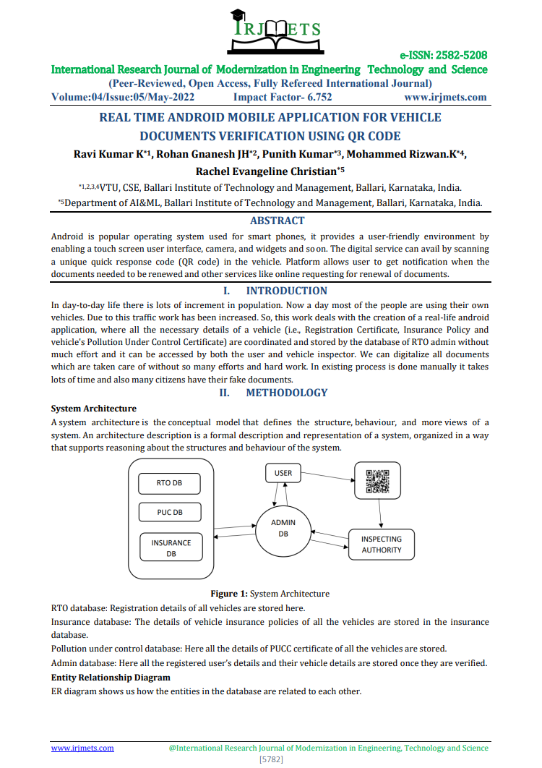

**PAPER PUBLICATION:**

Ms. Rachel Evangeline Christian, MD Rizwan K, Punith Kumar, Ravi Kumar K, Rohan Gnanesh JH

“REAL TIME ANDROID MOBILE APPLICATION FOR VEHICLE DOCUMENT VERIFICATION USING QR CODE” has been published at,

INTERNATIONAL RESEARCH JOURNAL OF MODERNIZATION IN ENGINEERING TECHNOLOGY AND SCIENCE (IRJMETS)

Volume: Volume 4, Issue 05, 40500315888, May 2022.

**PUBLICATION CERTIFICATES**

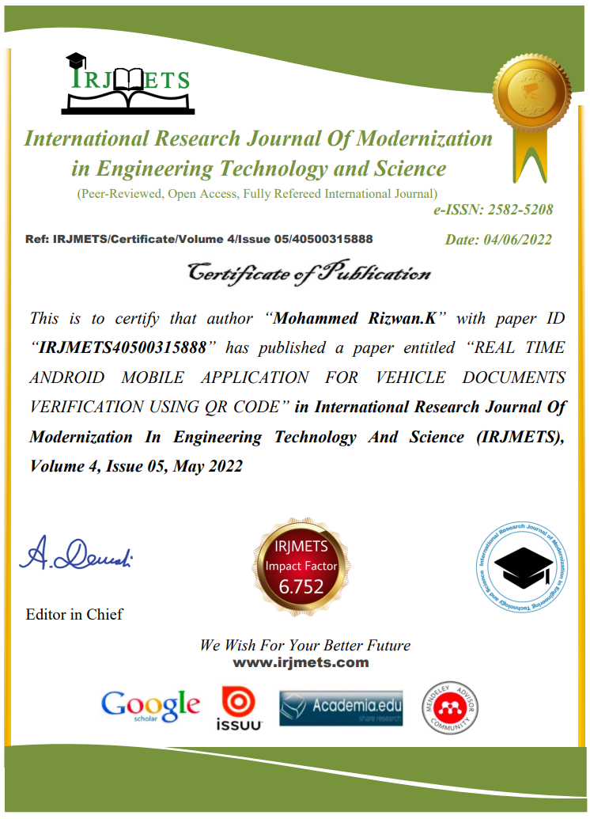

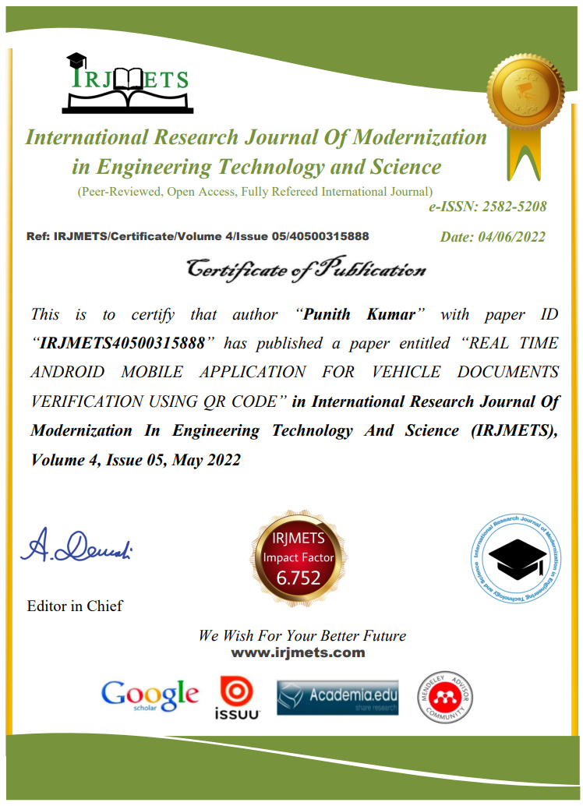

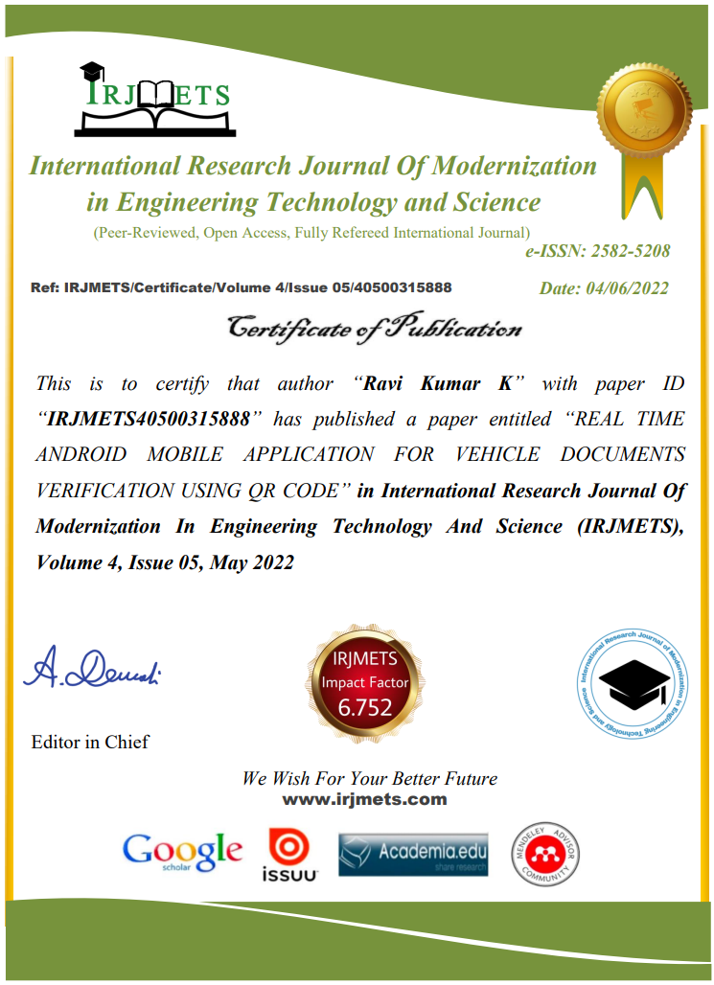

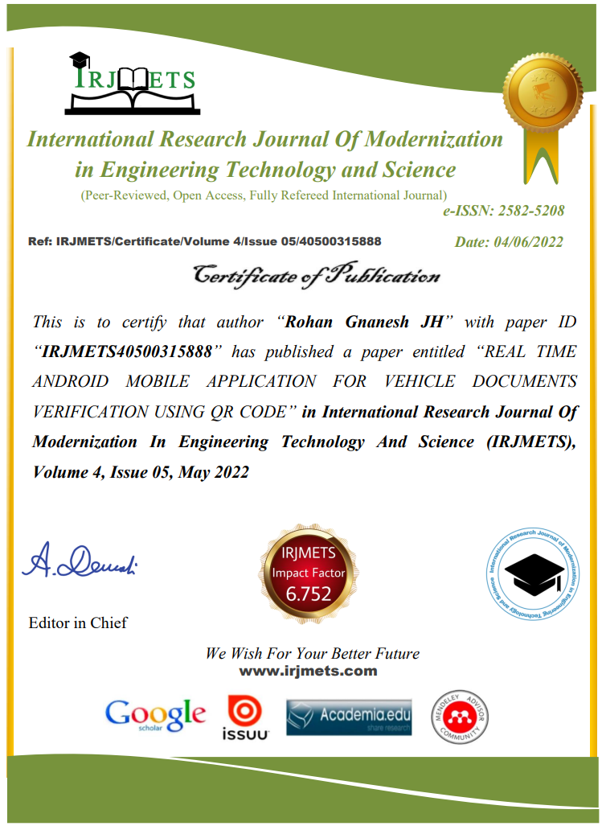

**BALLARI INSITUTE OF TECHNOLOGY AND MANGEMENT, BALLARI**

**DEPARTMENT OF COMPUTER SCIENCE & ENGINEERING**

**Project CO-PO Mapping**

**ACADEMIC YEAR 2021-22**

|  |  |  |  |
| --- | --- | --- | --- |
| **U.S.N.** | **Student Name** | **Guide Name** | **Project Title** |
| 3BR18CS098 | MD RIZWAN K | Ms. Rachel Evangeline Christian (Asst Prof) | Real Time Android Mobile Application for Vehicle Document Verification Using QR code |
| 3BR18CS123 | PUNITH KUMAR |
| 3BR18CS132 | RAVI KUMAR K |
| 3BR18CS133 | ROHAN GNANESH JH |

**COURSE OUTCOMES(CO'S)**

|  |  |
| --- | --- |
| **Course Outcomes**  **COx** | **Description of Course Outcomes** |
| **CO1** | **Identify** the problem in the present vehicle document verification system. |
| **CO2** | **Analyze** the problem in the present vehicle document verification system. |
| **CO3** | **Design** the android mobile application for vehicle document verification using QR code |
| **CO4** | **Write** technical Project report by following professional ethics |
| **CO5** | **Create** and publish the outcome of the thesis into an article |

**CO-PO MAPPING**

|  |  |  |  |  |  |  |  |  |  |  |  |  |  |  |
| --- | --- | --- | --- | --- | --- | --- | --- | --- | --- | --- | --- | --- | --- | --- |
| **CO-PO** | **PO1** | **PO2** | **PO3** | **PO4** | **PO5** | **PO6** | **PO7** | **PO8** | **PO9** | **PO10** | **PO11** | **PO12** | **PSO1** | **PSO2** |
| **CO1** | 1 | 1 |  |  | 1 |  |  |  |  |  |  |  |  |  |
| **CO2** |  | 3 |  | 1 |  |  |  |  |  |  |  |  |  |  |
| **CO3** |  | 1 | 3 |  | 1 |  |  |  |  |  |  |  |  |  |
| **CO4** |  |  |  |  |  |  |  |  |  | 3 |  | 1 | 1 |  |
| **CO5** |  |  |  |  |  |  |  | 1 | 1 | 2 |  | 1 |  | 1 |

|  |
| --- |
| **Signature of Guide**  Rachel Evangeline Christian |

**PROGRAM OUTCOMES AND PROGRAM SPECIFIC OUTCOMES**

|  |
| --- |
| **PO**1. **Engineering knowledge**: Apply the knowledge of mathematics, science, engineering fundamentals, and an engineering specialization to the solution of complex engineering problems.  **PO**2. **Problem analysis**: Identify, formulate, review research literature, and analyze complex engineering problems reaching substantiated conclusions using first principles of mathematics, natural sciences, and engineering sciences.  **PO**3. **Design/development of solutions**: Design solutions for complex engineering problems and design system components or processes that meet the specified needs with appropriate consideration for the public health and safety, and the cultural, societal, and environmental considerations.  **PO**4. **Conduct investigations of complex problems**: Use research-based knowledge and research methods including design of experiments, analysis and interpretation of data, and synthesis of the information to provide valid conclusions.  **PO**5. **Modern tool usage**: Create, select, and apply appropriate techniques, resources, and modern engineering and IT tools including prediction and modeling to complex engineering activities with an understanding of the limitations.  **PO**6. **The engineer and society**: Apply reasoning informed by the contextual knowledge to assess societal, health, safety, legal and cultural issues and the consequent responsibilities relevant to the professional engineering practice.  **PO**7. **Environment and sustainability**: Understand the impact of the professional engineering solutions in societal and environmental contexts, and demonstrate the knowledge of, and need for sustainable development.  **PO**8. **Ethics**: Apply ethical principles and commit to professional ethics and responsibilities and norms of the engineering practice.  **PO**9. **Individual and team work**: Function effectively as an individual, and as a member or leader in diverse teams, and in multidisciplinary settings.  **PO**10. **Communication**: Communicate effectively on complex engineering activities with the engineering community and with society at large, such as, being able to comprehend and write effective reports and design documentation, make effective presentations, and give and receive clear instructions.  **PO**11. **Project management and finance**: Demonstrate knowledge and understanding of the engineering and management principles and apply these to one’s own work, as a member and leader in a team, to manage projects and in multidisciplinary environments.  **PO12. Life-long learning**: Recognize the need for, and have the preparation and ability to engage in independent and life-long learning in the broadest context of technological change. |
| **PSO1. Understand the principles, architecture and organization of computers, embedded systems and computer networks**  **PSO2. To develop software applications using advanced technologies to cater the growing needs of industry.** |

**Project Guide**



Name: Rachel Evangeline Christian

Email: <rachel.ec@bitm.edu.in>

Phone no: 7259430565

**Project Associates**

Name: MD Rizwan K

USN: 3BR18CS098

Email: [rizwankhan586143786@gmail.com](mailto:rizwankhan586143786@gmail.com)

Phone no: 9036840786

Placement status: Placed

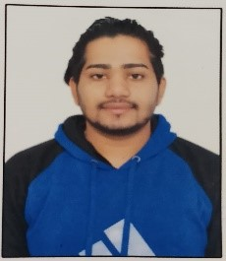

Name: Punith Kumar

USN: 3BR18CS123

Email: [punith584124@gmail.com](mailto:punith584124@gmail.com)

Phone no: 9663675108

Placement status: Placed





Name: Ravi Kumar K

USN: 3BR18CS132

Email: [koteravi.2580@gmail.com](mailto:koteravi.2580@gmail.com)

Phone no: 7829490036

Placement status: Placed

Name: Rohan Gnanesh JH

USN: 3BR18CS133

Email: [rohanjh44@gmail.com](mailto:rohanjh44@gmail.com)

Phone no: 9380649497

Placement status: Placed

